The basic physical Capacities
As we have seen in the previous course, the basic physical capacities constitute the pillars on which the physical condition is built..
When we talk about basic physical capacities, we refer to the endurance, the strength, the speed and the flexibility that our organism possesses. Therefore, the greater the degree of development of the same, the better our physical condition will be.
A good physical condition is essential to lead an active and healthy life. Therefore, we must stay in shape because it will help us to have a better quality of life and in the absence of diseases.
Here is a brief definition of each physical capacity and the benefits that are obtained with your regular physical activity.
Endurance:
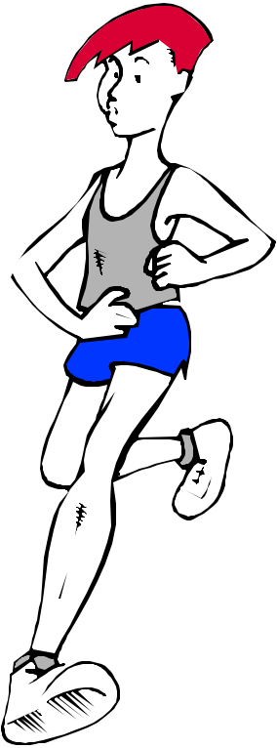
We understand by endurance the capacity of our organism to support efforts in a continuous way. That is to say, that capacity that allows us to carry out a physical exercise for as long as possible. It is closely related to cardiovascular and respiratory health, with weight control, the immune system, etc.
There are two types of endurance, in the next courses we will learn how to distinguish them and understand them better. Now, you only have to know that we distinguish between:
Aerobic Endurance: This one allows us to perform exercises of moderate intensity for a long time (for many minutes, even hours)
Anaerobic Endurance: It allows us to withstand more intense efforts, but for less time and therefore we get tired relatively soon.
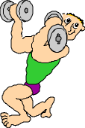
Strength:
Strength constitutes the capacity that our organism has to overcome or counteract a certain resistance.
The proper work of strength entails an improvement of body posture, muscle tone, can help reduce the risk of injury and discomfort in the neck, back and even improve our physical appearance.
Speed:
Speed constitutes the basic physical capacity that allows us to make a movement or a series of them in the shortest possible time. If you try to respond to a stimulus as quickly as possible, we will be talking about reaction speed, gestural speed making a move as fast as possible and speed of travel traveling a distance in the shortest possible time.
Flexibility:
It is the capacity that allows us to achieve the greatest possible range of motion and is determined by the joint mobility and muscular elasticity. Flexibility is a capacity that has its highest levels when we are born, and we are losing day after day. Therefore, we must work to maintain a high degree of flexibility and joint mobility as it directly influences our posture and the health of our locomotive system.
Among the benefits obtained by the specific work of each of the basic physical capacities, we can highlight the following:

Endurance | - Increased working time by reducing fatigue.  - In the long term, it decreases the risk of cardiovascular disease.  - Optimal weight control.  - It makes it easier to make efforts by beating a resistance in daily life.  - Improves physical appearance.
Strength | - It’s easier to make efforts by beating a resistance in daily life.  - Improves body posture and physical appearance.
Flexibility | - It prevents the risk of injury caused by muscular overloads.  - Reduces the involution that begins at a very early age.  - Improves body posture.  - Improves the quality of the movements.
Speed | - It allows you to react more effectively to different stimuli.  - Helps controls the speed of execution and gestural.

- Think about:
Explains three stretches and that muscle is involves.
1

Think and write 3 exercises that you have done on occasion to develop the strength of your muscles and are suitable for your age.
2
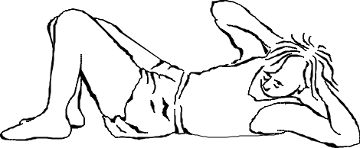

3

Sorts the following sports according to what kind of physical capacity it develops and add two more examples of each:
Aerobic Endurance:

Strength:

