STRENGTH. TYPES OF STRENGTH AND TRAINING METHODS
Strength is the ability to overcome, stop, or oppose a resistance through muscular action. There are different types of strength and exercise or training methods. We are going to learn about three types of strength:

- Maximum strength.- is the ability to overcome a resistance or heavy weight; it is the highest strength that can manifest in a muscular contraction. An typical example of a sport that needs this kind of strength is weight lifting.
- Explosive strength.- is the ability to overcome a resistance or weight quickly. This is also called Potential. A typical example of this type of strength are jumps, hits, throws, etc...

- Resistance strength.- is the ability to endure or support a long and continuous effort of strength. This type is illustrated most to improve health. Kinds of sports that need this type of strength include rowing, judo, climbing, etc...

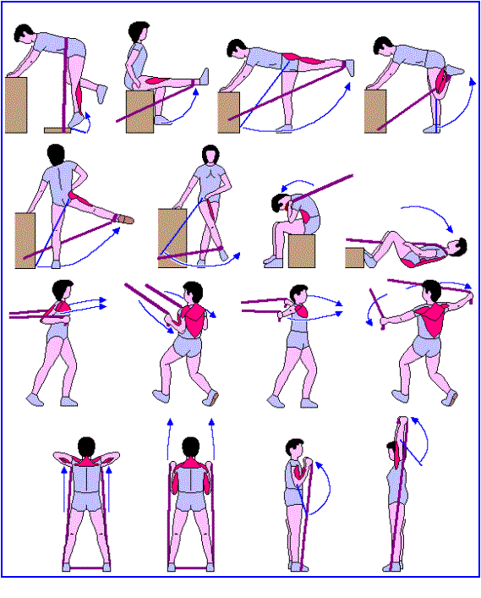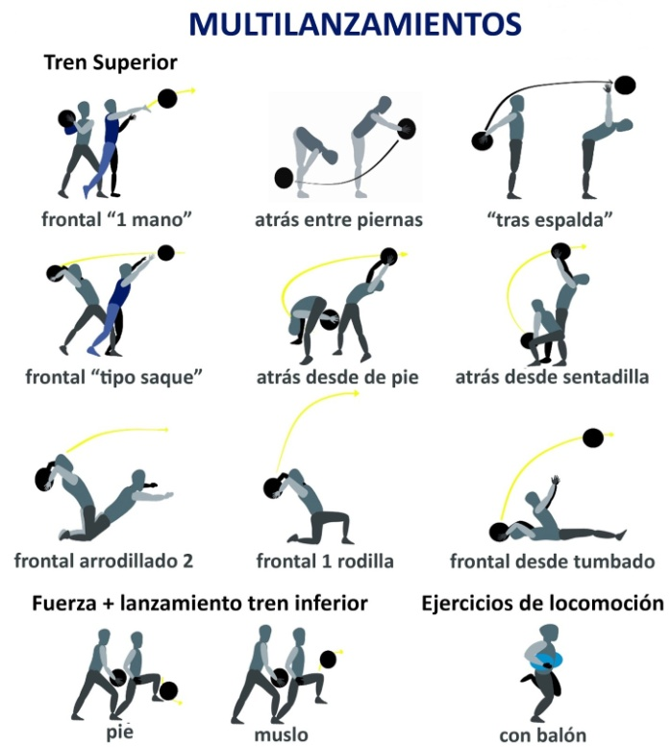 Maximum Strength with Weights Resistance Strength with Bands
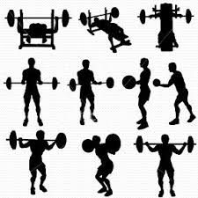

Depending on the sport we practice, we will need to develop one type of strength or another; but the most important thing to know is that your age (between 15 and 18 years old) shouldn´t work at maximum capacity because it can be detrimental to your growth. Strength resistance is most related to health (strengthening of bones, muscles, and joints, improves posture, increases metabolism, improves aesthetics, etc...).
Basic Concepts:
- Repetition: Number of times that you perform an exercise
- Series: Groups of repetitions separated by rest periods
- Weight: Resistance to overcome.
- Rest: Recuperation period between series or exercises
Design your own circuit:
- Design a workout aimed at improving strength that is most appropriate for you, based on your age and goal.
- When designing, keep the structure of a proper workout in mind: Warm-up, Main part, Cool down.
- Include join mobility and stretching in the warm-up and cool-down.
- Avoid performing contradicting exercises. Your back is the most important thing.
- Alternate exercises so as to not workout the same muscles/parts of the body the entire time.
- You can perform exercises by time or repetitions.
- Indicate the principal muscular group in each exercise.
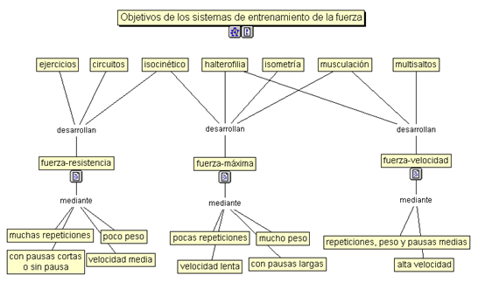

Circuit:

Goal:

Number of exercises:

Series:

Repetitions:

Rest:

Weight:

Execution Speed:

Equipment:

Observations:

