Physical condition and health assessment

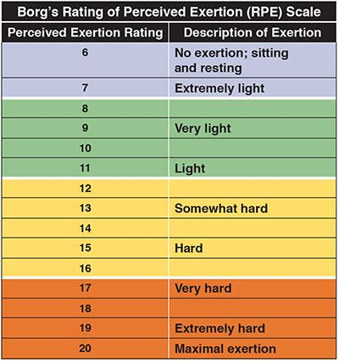
- Assess the intensity of the exercise:
Remember that we gain the greatest cardiovascular benefits when we work between 60% and 80% of our Maximum Heart Rate.
(220 – Age)
It is important that you learn to control intensity to run during the necessary time so that we produce the benefits we’re looking for, and also so that you achieve the goal!
To do this, in addition to heart rate (HR), we are going to use an instrument that will help you control this intensity: the perception of exertion, or Borg Scale. (RPE)

Activity | Distance | HR | RPE
… minutes run
… minutes run
… minutes run
… minutes run
… minutes run

- Assess your progress: Do you know how to control the intensity of your run? Do you think you have chosen the appropriate rhythm? Do you think you have run within healthy limits?
- Assess your health-related fitness components: aerobic capacity, body composition, and muscular strength, endurance, and flexibility.
- Think deeply about your healthy habits (rest, nutrition, locomotor pains, injuries, diseases, consumption habits…)
How do you think you can improve it? Suggest widely improvements.

